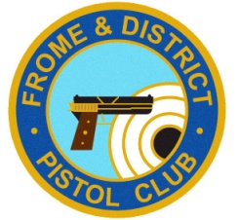 | FDPC – Open Competition Proposal Form  This form needs to be completed and submitted (with preferably 8 weeks notice) to the Committee, for approval for any Open competition that involves shooters that are not  FDPC members.
Title of Competition
Proposed Comp Date
Proposed Set-up and clear-down Dates
Proposed timings
Match Director (Must be Full FDPC member)
Details of entry fees
Entry Restrictions
Predicted income
Predicted expenditure
Predicted profit
Sponsorship
Range requirements
Range Kit
Route for entries
Range Crew (named)
Stats & squadding arrangements
Facilities arrangements
Other relevant Information for Committee to consider
What support or assistance might you need from the Committee?

